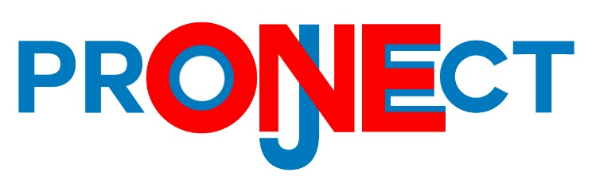

**What is the ONE Project?**

The ONE Project is a faith and community coalition organized to efficiently and effectively address social needs through education and volunteerism.

**What is the NJ Hunger Project?**

This is the ONE Project’s kick-off event and will bring people together in order to provide 40,000 nutritious meals to low-income children in our community. We are working with Feeding Children Everywhere and Mercer Street Friends Food Bank to distribute these meals to kids through the “Send Hunger Packing” program. On July 26th at Robbinsville High School at 10AM we will be working together to package and deliver the 40,000 meals. Please come out and feel free to volunteer the day of the event.

**What is Feeding Children Everywhere?**

Feeding Children Everywhere is a social charity that empowers and mobilizes people to assemble healthy meals for hungry children.

**What is in the FCE Meal?**

The FCE Meal is a lentil casserole designed by nutritionists. It consists of Lentils - a bean that is a great source of protein and fiber, white rice, vegetables, and pink Himalayan salt – which contains 84 trace minerals. The meal is made of all-natural ingredients and is non-perishable.

**What is Mercer Street Friends Food Bank?**

MSF is a Mercer County based food bank that supplies over 2.5 million pounds of food each year to more than 60 organizations in Mercer County including the Trenton Area Soup Kitchen, Homefront, Crisis Ministry, and The Rescue Mission of Trenton. They feed over 25,000 people at risk of hunger in the county.

**What is the Send Hunger Packing Program?**

There are children in our community who live in households where there is not enough income or resources to adequately feed the family. School Breakfast and Lunch programs provide meals to these children Monday through Friday. But what happens on the weekends? Do the children get enough to eat over the weekend or do they go hungry?

The Send Hunger Packing program meets the needs of these hungry children by providing them nutritionally sound food to eat over the weekend and school breaks. The FCE meals along with other nutritious food are providing to the children in backpacks that they take home.

**TO DONATE, VOLUNTEER, OR LEARN MORE VISIT:**

http://www.feedingchildreneverywhere.com/portfolio-items/one-project/

**CONTACT: ONEPROJECTNJ@GMAIL.COM**